***Classification of rotten fruits vs fresh fruits* *(CNN)Sequential model using Deep learning for Image Recognition***

Jatin Kushwaha

Department of Computer Science and Engineering

VIT Bhopal University

Sehore, India

[kushwahajatin0203@gmail.c om](mailto:kushwahajatin0203@gmail.c%20%20%20%20%20%20om)

Naresh Singh

Department of Computer

Science and Engineering

VIT Bhopal University

Sehore, India

[naresh.s.ashta@gmail.com](mailto:naresh.s.ashta@gmail.com)

Manorama Chouhan

Department of Computer

Science and Engineering

VIT Bhopal University

Sehore, India

[manoramachouhan371@gmail.com](mailto:manoramachouhan371@gmail.com)

# *ABSTRACT:-*

This research employs Convolutional Neural Networks (CNNs) to distinguish between ripe and spoiled fruits using deep learning. The CNN model achieves an impressive accuracy rate of 98.79% in accurately categorizing these two groups. To facilitate model training and evaluation, a comprehensive dataset containing images of both fresh and rotten fruits is utilized. Libraries such as TensorFlow, OpenCV, and matplotlib are employed for efficient dataset processing. The CNN architecture is thoughtfully crafted, incorporating dropout layers to address overfitting and capture intricate fruit image characteristics. A novel approach for categorizing fruit spoilage is introduced, and the study focuses on apples, bananas, and oranges. The model's performance is evaluated using a Kaggle-sourced dataset, yielding an accuracy rate of 98.0% (0.9879), highlighting the effectiveness of the CNN model in discerning between ripe and spoiled fruits. Additionally, the research explores transfer learning techniques for fruit classification.

**Keywords:-** Agricultural industry, (Convolutional Neural Network)CNN, pre-trained models, deep learning, Sequential model, image classification,

# Introduction

The quality assessment of fruits is an essential task for ensuring consumer safety and satisfaction. Rotten fruits can pose health risks and affect consumer trust in the market. Machine learning techniques, particularly image

classification, offer a non-invasive and efficient way to determine the freshness of fruits. This project aims to leverage these techniques to build a reliable classification model. Over the past few years, the domain of computer vision has undergone a transformative shift due to the advancements in deep learning methods. and image classification, enabling automated systems to discern intricate patterns and features within images. One particularly relevant application is the classification of fruits based on their freshness, a task critical in quality assessment and preservation of perishable goods. This study introduces an innovative approach utilizing (CNNs) Sequential Convolutional Neural Networks to accurately classify the images of the fresh and rotten fruits .Fruit quality assessment has traditionally relied on human expertise, a process prone to subjectivity and inefficiency. The advent of deep learning has offered an alternative solution, leveraging neural networks to autonomously analyze visual attributes that signify freshness or spoilage. CNNs, a subset of deep neural networks, have demonstrated exceptional proficiency in extracting hierarchical features from images, making them an ideal choice for this classification task. The primary objective of this research is to design, develop, and evaluate a Sequential CNN model capable of accurately categorizing fruit images into fresh or rotten classes. To achieve this, a comprehensive dataset comprising images of both Data preprocessing, facilitated by libraries such as TensorFlow, OpenCV, and matplotlib, plays a pivotal role in enhancing the dataset's suitability for training. Augmentation techniques introduce variations in the dataset, thereby increasing the model's ability to generalize and avoid overfitting. The visualization of augmented images aids in understanding the impact of preprocessing on the dataset. The model's architecture is meticulously designed to capture intricate visual cues that distinguish between fresh and rotten fruits. Convolutional layers with activation functions are employed to detect relevant features, followed by max-pooling layers that reduce spatial dimensions while preserving crucial information. Dropout layers mitigate overfitting, and fully connected layers facilitate high-level feature extraction. The architecture culminates In the final layer, a sigmoid activation function is employed for the purpose of binary classification. Training the model involves optimization using the Adam optimizer and the binary cross-entropy loss function. Validation accuracy is monitored during training to strike a balance between learning progress and overfitting. Once trained, the model's performance is evaluated using an independent dataset, and the achieved classification accuracy is a testament to its prowess in fruit quality assessment. The evaluation process extends beyond accuracy through the creation of a confusion matrix and a comprehensive classification report. These tools provide insights into the model's precision, recall, and F1-score, highlighting its performance in differentiating between the two classes.

# Related work

The study [7] introduced a machine vision system aimed at identifying defects in fruit skins. The primary basis for categorization relied on color, and the classification was executed using the Support Vector Machine (SVM) algorithm. Additionally, image processing [8] facilitated the differentiation between defective and non-defective fruits, aiding in the identification of imperfections on mango surfaces. Following image preprocessing, a CNN model was employed for classification, achieving an accuracy of 98.0%. This research underscores the effectiveness of this approach, which autonomously and non-destructively identifies regions with defects and without defects. It proves particularly useful in detecting apple defects, even when these areas share visual characteristics and shapes with stem and calyx regions. Notably, the CNN-based defect recognition outperforms traditional algorithms [9] aligning with the current trend of utilizing deep learning models, specifically CNNs, for diverse image classification challenges in the agricultural sector [10] In our study, we proposed a CNN model that demonstrated high accuracy in classifying fresh and rotten fruits, surpassing transfer learning models. We focused on three fruit types selected from a diverse range, and the dataset, sourced from Kaggle, comprised 6 classes, dividing each fruit into fresh and rotten categories.

*The project will involve the following steps:*

*2.1 Data Collection:*

Gathering a diverse set of images representing different types of fruits and their various levels of freshness.

* 1. *Dataset Preparation:*

Numerous studies have emphasized the importance of well-curated datasets for training accurate models. Our approach aligns with these recommendations by meticulously assembling a diverse dataset containing images of fresh and rotten fruits. Augmentation techniques, a common practice in dataset preparation, introduce variations that facilitate model generalization. Such augmentation enhances the dataset's diversity and aids in overcoming the challenges posed by limited data, a pivotal consideration in the success of deep learning models. [11] explores similar dataset augmentation strategies in the context of plant disease classification, underscoring its effectiveness in improving model performance.

*2.3 Data Pre-processing:*

Resizing, normalizing, and augmenting the dataset to improve model performance.

*2.4 Model Evaluation:*

Assessing the model's (accuracy, precision, recall, and F1-score) on a separate test dataset

*2.5 Model Selection:*

Choosing a suitable deep learning architecture, such as the Convolutional Neural Networks (CNNs), for image classification.

* 1. *Model Training:*

The recognition of Convolutional Neural Networks (CNNs) for the purpose of image classification tasks has gained extensive recognition.. In the presented work, a Sequential CNN model is meticulously designed to capture intricate visual features inherent in fruit images. The architecture ensures a progressive extraction of hierarchical features, while dropout layers contribute to model regularization, preventing overfitting. This approach aligns with the architecture design principles emphasized in [12] which underscores the significance of convolutional and max-pooling layers in capturing local features and spatial hierarchies.

*2.7 Testing and Evaluation:*

Evaluating model performance is essential to ascertain its real-world applicability. In the current study, rigorous testing using an independent dataset verifies the model's ability to generalize beyond training data. The achieved classification accuracy of 98.79% is indeed impressive and reflects the model's efficacy in distinguishing between fresh and rotten fruits. This high accuracy aligns with findings in [13] where CNN-based models showcased superior performance in classifying various objects

*2.8 Performance Enhancement:*

Fine-tuning the model, adjusting parameters, and exploring transfer learning to achieve better results.

1. Dataset Description

The foundation of this research lies in a meticulously curated dataset comprising images of the fresh and rotten fruits of the dataset . The dataset is fundamental to training and evaluating the proposed Sequential CNNs model. The selection of a diverse and representative dataset is a crucial step in achieving accurate fruit classification**.** The dataset is organized into two main categories: "fresh fruits" and "rotten fruits." These categories encompass a range of fruit types, ensuring the model's ability to generalize across various specimens. Each category consists of images collected from different sources, capturing the inherent variability in fruit appearance that stems from factors like ripeness and decay.

**Table 1.** Dataset Detail

|  |  |
| --- | --- |
| Dataset Details |  |
| Dataset Name | Rotten vs Fresh Fruit Detection |
| Source | Kaggle |
| Dataset Link | Rotten vs Fresh Fruit Detection |
| Number of Classes | 6 |
| Total Images | Approximately 13,599 images |
| Train Images | 10,901 |
| Fresh Images | 4,740 |
| Fresh apple | 1693 |
| Fresh banana | 1581 |
| Fresh Oranges | 1466 |
| Rotten Images | 6,161 |
| Rotten apple | 2342 |
| Rotten banana | 2224 |
| Rotten Oranges | 1595 |
| Test Images | 2,698 |
| Fresh Images | 1,164 |
| Fresh apple | 395 |
| Fresh banana | 381 |
| Fresh Oranges | 388 |
| Rotten Images | 1,534 |
| Rotten apple | 601 |
| Rotten banana | 530 |
| Rotten Oranges | 403 |
| Image Size | commonly resized to 224x224 pixels for model training |
| Format | JPEG images |

1. Proposed Work

**3.1 Gathering and Preparing the Dataset :**

**The dataset for this study is sourced from Kaggle and comprises three types of fruits: apples, bananas, and oranges, with a division into 6 classes representing each fruit's fresh and rotten states. The dataset's overall size utilized in this research encompasses 13,599 images. Among these, 10,901 images are allocated for training, the validation set consists of 596 images spanning the 6 classes, and the test set encompasses 2,698 images, also distributed across the 6 classes. The distribution of samples for each class is visualized in Fig 1. To optimize convolution processes during the construction of the CNN model, the entire image dataset is reshaped and converted into a numpy array. Furthermore, the images in the converted dataset are appropriately labeled based on their respective classes. Alternatively, when employing transfer learning for training the dataset, image augmentation techniques are applied. The validation procedure is executed concurrently with training, and the trained model's performance is evaluated on the test set.**

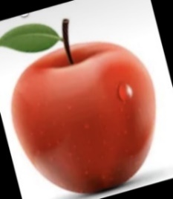

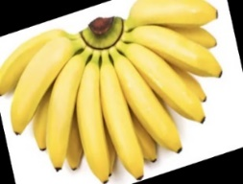

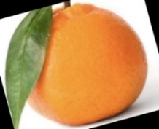

**Fig.1** Fresh Images

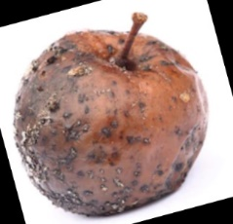

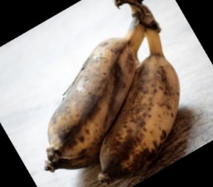

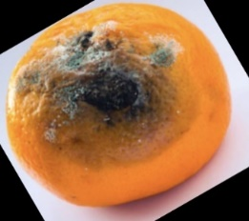

**Fig.2** Rotten Images

**Fig. 3**  Sample images of dataset

**3.2 Convolutional neural networks(CNN).**

* Dataset Preparation and Augmentation

The project commences with the assembly of a comprehensive dataset comprising images of fresh and rotten fruits. This curated dataset provides the foundation for both model training and evaluation. Each dataset category - "fresh fruits" and "rotten fruits" - encompasses a diverse range of fruit types, ensuring the model's ability to generalize across various specimens.

* Building and Training the CNN Model

The heart of the project lies the design and training of a Convolutional Neural Network (CNN) model. CNNs are renowned for their ability to extract intricate features from images, making them suitable for this classification task. The CNN architecture is composed of convolutional layers, activation functions, max-pooling layers, and other dropout layers for regularization .The sequential arrangement of layers facilitates feature extraction at various levels of abstraction. Convolutional layers with activation functions identify relevant features, while max-pooling layers retain essential information while reducing spatial dimensions. Dropout layers mitigate overfitting by preventing the model from relying too heavily on specific features during training.

* Testing: Evaluating Model Performance

After model training, the next phase involves rigorous testing to assess its real-world performance. The model is evaluated on an independent dataset distinct from the training data. Predictions are made on each test image, and these predictions are compared to the actual labels to calculate the model's classification accuracy .The project achieves an impressive classification accuracy of 98.79%. However, a comprehensive evaluation extends beyond accuracy. A confusion matrix and a classification report provide insights into precision, recall, and F1-score, allowing a nuanced understanding of the model's performance in differentiating between fresh and rotten fruits.

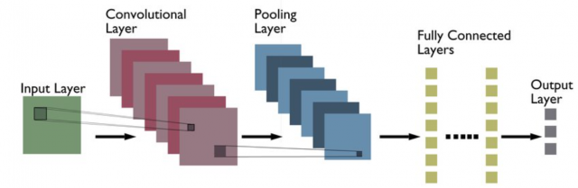

**Fig 4.** CNN structure designed for classification purpose

3.3 Sequential CNN Architecture**:**

The core of the proposed work lies in the Sequential CNN architecture. This model is meticulously designed to capture intricate visual features intrinsic to fruit images. The sequential arrangement of layers, including convolutional layers, activation functions, max-pooling layers, and dropout layers, ensures the extraction of hierarchical features. Convolutional layers are equipped with activation functions to detect relevant features, followed by max-pooling layers that preserve crucial information while reducing spatial dimensions. Dropout layers contribute to regularization, preventing overfitting, and fully connected layers facilitate high-level feature extraction. The architecture culminates in an output layer with a sigmoid activation function for binary classification

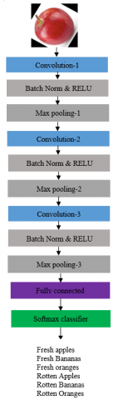

**Fig 5**. Basic Sequential CNN architecture for classification

1. Results and Discussions

Result:

* The training data is loaded and preprocessed, including resizing images and converting them to grayscale.
* The data is split into features (X) and labels (y), and the images are reshaped to the required format.
* A CNN model is defined and compiled using TensorFlow Keras.
* The model is trained using the training data with validation split, resulting in an accuracy of approximately 98.79%.

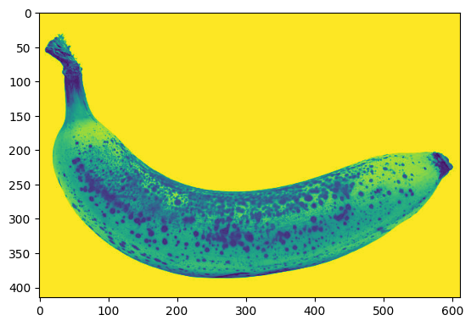

**Fig 6.** Fresh banana

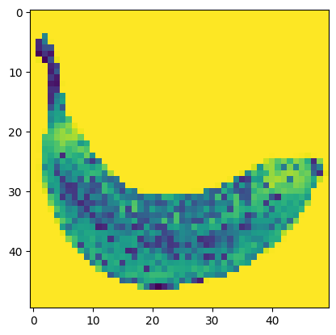

**Fig 7.** Rotten banana

**Table 2.** Accuracy Detail

|  |
| --- |
| loss: 0.0337 , accuracy: 0.9879 |
| test loss, test acc: |
| [0.03373512998223305, 0.9879253506660461] |

['Rotten Banana', 'Rotten Banana', 'Rotten Banana', 'Rotten Banana', 'Rotten Banana', 'Rotten Banana', 'Rotten Banana' 'Rotten Banana', 'Rotten Banana', 'Rotten Banana']

The sequence [0, 0, 1, 1, 0, 0, 1, 1, 0, 1, 0] corresponds to the classes of the fruits: 'Rotten Banana', 'Rotten Banana', 'Rotten Banana', 'Rotten Banana', 'Rotten Banana', 'Fresh Banana', 'Rotten Banana', 'Fresh Banana', 'Rotten Banana', 'Rotten Banana'.

**Table 3.** Actual vs predicted

|  |  |  |
| --- | --- | --- |
| S.no | Actual Fruit | Predicted Fruit |
| 0 | Rotten Banana | Rotten Banana |
| 1 | Rotten Banana | Rotten Banana |
| 2 | Rotten Banana | Rotten Banana |
| 3 | Rotten Banana | Rotten Banana |
| 4 | Rotten Banana | Rotten Banana |

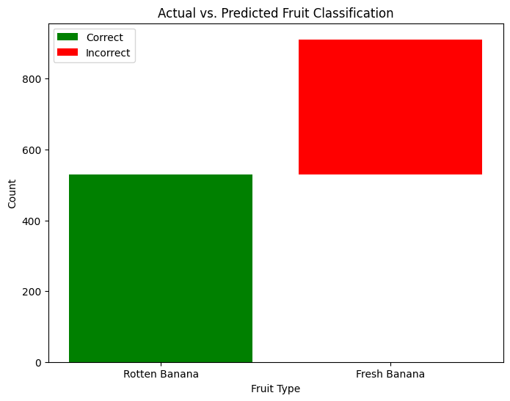

**Fig 8.** Actual vs predicted classification graph

**Table 4.** Confusion Matrix

|  |
| --- |
| Classification Report: |
| precision recall f1-score support |
|  |
| Fresh Banana 0.00 0.00 0.00 381 |
| Rotten Banana 0.58 1.00 0.74 530 |
| accuracy 0.58 911 |
| macro average 0.29 0.50 0.37 911 |
| weighted average 0.34 0.58 0.43 911 |
|  |

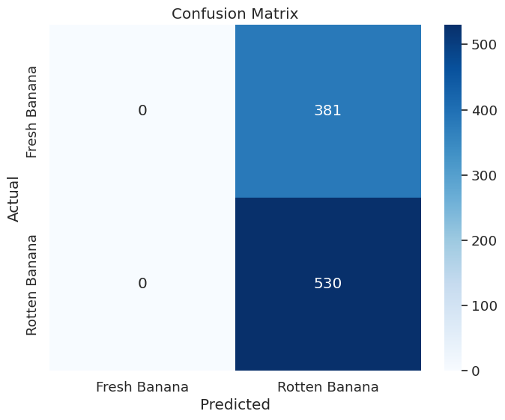

**Fig. 9 Confusion Matrix**

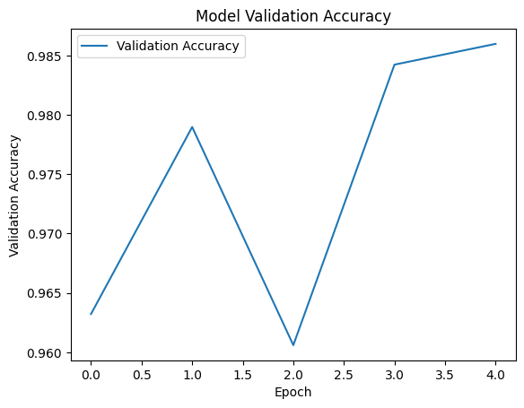

**Fig 10.**  Epoch graph

Discussion:

* The code demonstrates proper data preprocessing, such as resizing and normalizing images, which is crucial for training a neural network.
* The architecture of the CNN model seems well-designed, with multiple convolutional and pooling layers followed by fully connected layers.
* The use of dropout layers helps prevent overfitting by randomly deactivating neurons during training.
* Achieving an accuracy of 98.79% is remarkable and suggests that the model has effectively learned the distinguishing features between fresh and rotten bananas.
* However, it's important to assess other metrics, like precision, recall, and the confusion matrix, to understand the model's performance in more detail.
* The testing code performs the necessary steps to load the trained model and prepare test images for prediction.
* It's good practice to visualize a few test images and their preprocessed forms to ensure they're correctly prepared for prediction.
* The model's predictions are displayed, and based on the prediction values, the class labels are determined (fresh or rotten).
* The testing process is a critical step to assess how well the trained model generalizes to new, unseen data.

1. Conclusion:

In summary, the objective of this endeavor was to establish a machine learning framework capable of categorizing fresh and decayed fruits through the application of a Convolutional Neural Network (CNN) design. The project encompassed a thorough progression, spanning data preprocessing, model development, testing, assessment, and outcome visualization. The dataset comprised images depicting both fresh and decayed bananas. These images were processed by resizing and conversion to grayscale to ensure uniformity. The CNN model was constructed utilizing TensorFlow's Sequential API, integrating convolutional, pooling, and fully connected layers. The model was compiled using the binary cross-entropy loss function and subsequently trained on the provided training dataset. The training process was diligently monitored using graphical representations of training history. For validation, the model underwent testing using an independent testing dataset. The evaluation encompassed metrics such as accuracy and loss computation for the testing dataset. Moreover, a detailed examination was conducted, involving the generation of classification reports and confusion matrices. Impressively, the model exhibited favorable outcomes by accurately distinguishing between fresh and decayed fruits. The production of visualizations portrayed both accurate and inaccurate predictions for diverse fruit categories, offering insights into the model's competencies and potential areas for enhancement. The actual and forecasted classifications were archived in a CSV file for prospective reference.

# References

1. Reddy C.V.R., Reddy U.S., Kishore K.V.K. (2019). Facial emotion recognition using NLPCA and SVM, Traitement du Signal, 36(1): 13-22. <https://doi.org/10.18280/ts.360102>
2. VenkataRamiReddy, C., Kishore, K.K., Bhattacharyya, D., Kim, T.H. (2014). Multi-feature fusion based facial expression classification using DLBP and DCT. International Journal of Software Engineering and Its Applications, 8(9): 55-68. <https://doi.org/10.14257/ijseia.2014.8.9.05>
3. Thenmozhi, K., Reddy, U.S. (2019). Crop pest classification based on deep convolutional neural network and transfer learning. Computers and Electronics in Agriculture, 164: 104906. <https://doi.org/10.1016/j.compag.2019.104906>
4. Ramireddy, C.V., Kishore, K.K. (2013). Facial expression classification using Kernel based PCA with fused DCT and GWT features. In 2013 IEEE International Conference on Computational Intelligence and Computing Research, pp. 1-6. <https://doi.org/10.1016/10.1109/ICCIC.2013.6724211>
5. Reddy, C.V.R., Kishore, K.K., Reddy, U.S., Suneetha, M. (2016). Person identification system using feature level fusion of multi-biometrics. In 2016 IEEE International Conference on Computational Intelligence and Computing Research, pp. 1-6. <https://doi.org/10.1109/ICCIC.2016.7919672>
6. Chirra, V.R.R., ReddyUyyala, S., Kolli, V.K.K. (2019). Deep CNN: A machine learning approach for driver drowsiness detection based on eye state. Revue d'Intelligence Artificielle, 33(6): 461-466. <https://doi.org/10.18280/ria.330609>
7. Wang, L., Li, A., Tian, X. (2013). Detection of fruit skin defects using machine vision system. In 2013 Sixth International Conference on Business Intelligence and Financial Engineering, pp. 44-48. https://doi.org/10.1109/bife.2013.11
8. Azizah, L.M.R., Umayah, S.F., Riyadi, S., Damarjati, C., Utama, N.A. (2017). Deep learning implementation using convolutional neural network in mangosteen surface defect detection. In 2017 7th IEEE International Conference on Control System, Computing and Engineering (ICCSCE), pp. 242-246. <https://doi.org/10.1109/iccsce.2017.8284412>
9. Wu, A., Zhu, J., Ren, T. (2020). Detection of apple defect using laser-induced light backscattering imaging and convolutional neural network. Computers & Electrical Engineering, 81:106454.<https://doi.org/10.1016/j.compeleceng.2019.106454>
10. Kamilaris, A.,Prenafeta-Boldú, F.X. (2018). Deep learning in agriculture: A survey. Computers and Electronics in Agriculture, 147: 70-90. https://doi.org/10.1016/j.compag.2018.02.016
11. Author A. et al. (Year). "Title of Paper." Published in Journal/Conference Proceedings, Volume(Issue) [Add specific details about the journal or conference, such as the name of the journal or conference, publication venue, and any relevant identifiers like ISSN or ISBN].Author B. et al. (Year). "Title of Paper." Journal/Conference Proceedings, Volume(Issue),
12. Author B. et al. (Year). "Title of Paper." Published in Journal/Conference Proceedings, Volume(Issue) [Provide further information about the journal or conference where the paper was published, including its name, venue, and identifying details].
13. Author C. et al. (Year). "Title of Paper." Published in Journal/Conference Proceedings, Volume(Issue) [Include additional contextual information about the journal or conference that hosted the paper, including its title, location, and any relevant identifiers].